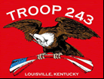
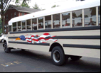
TROOP 243
June 1st, 2010
Boy Scouts of America
Chartered by St. Barnabas Catholic Church

3044 Hikes Lane Louisville, Ky 40220
http://www.troop243.com

Dear Parents and Friends of Troop 243,

Troop Outings & Activities – June starts out by wrapping up our meetings that focus on Boating. Summer camp medical forms are due to Jay Groves by June 6th. Two opportunities to attend National Youth Leadership Training are offered in June. Summer Camp is the week of June 21st and we start focusing on Aquatics at our Troop meetings.

Troop and Patrol Meetings on Wednesdays - All are welcome. Scouts in Class A uniforms are expected. Except where noted, all meetings are held at St. Barnabas.

June 2nd, 7:00 PM – Boating
June 9th, 7:00 PM – Patrol Meeting
June 16th, 7:00 PM – Aquatics
June 23rd, 7:00 PM – Summer Camp – No Troop meeting
June 30th, 7:00 PM - Aquatics

Court of Honor – Our most recent Court of Honor, held on May 19th, was attended by the Lincoln Heritage Council in order to properly recognize Troop 243’s Cobra Co-advisor Kelly Yates for completing Woodbadge training. Woodbadge Training is the highest level of scout training that can be achieved by an adult leader. It is however valuable training that will provide knowledge that can be used in private industry. Below left is Mr. Yates with his family receiving his award. Thank you Mr. Yates for your commitment to improving our troop’s leadership! Below right is Mark Renn receiving his Eagle Scout award. While we generally dedicate a Court of Honor to a new Eagle Scout, Mark chose a lower key ceremony but the achievement is substantial just the same. Congratulations Mark!

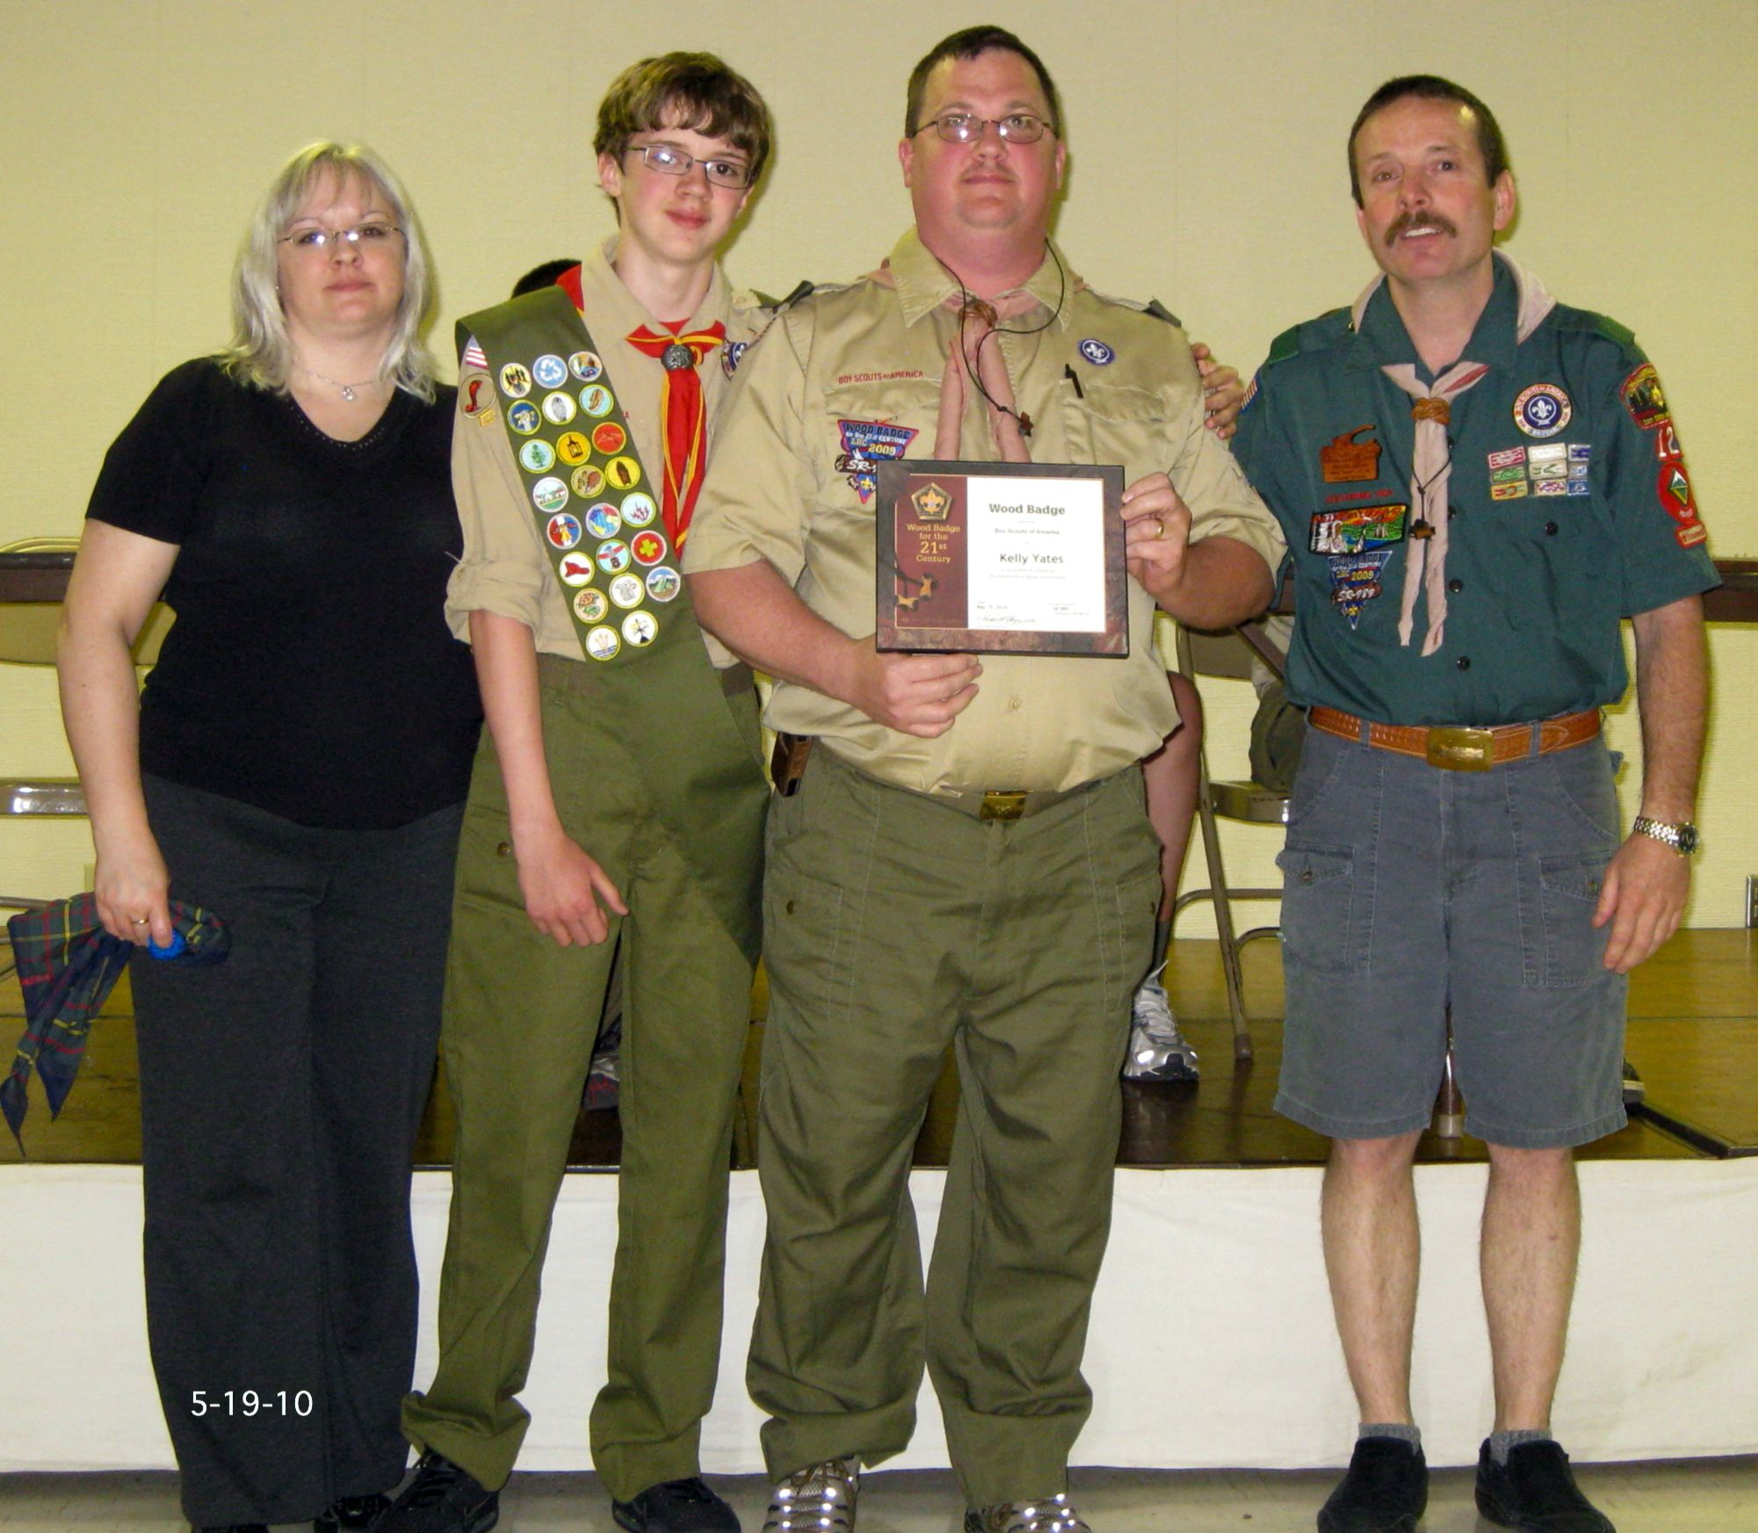
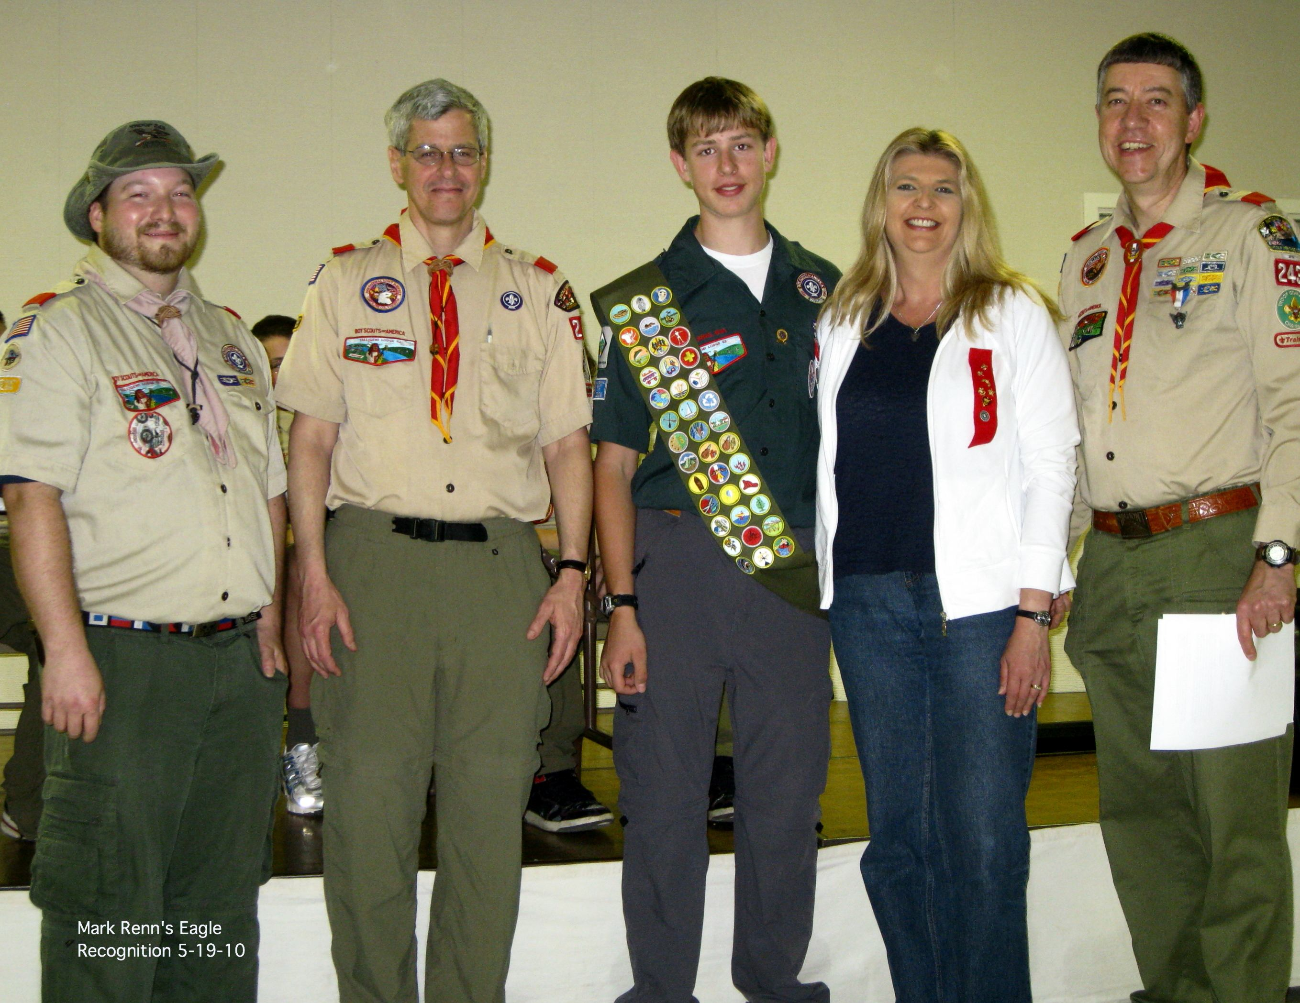

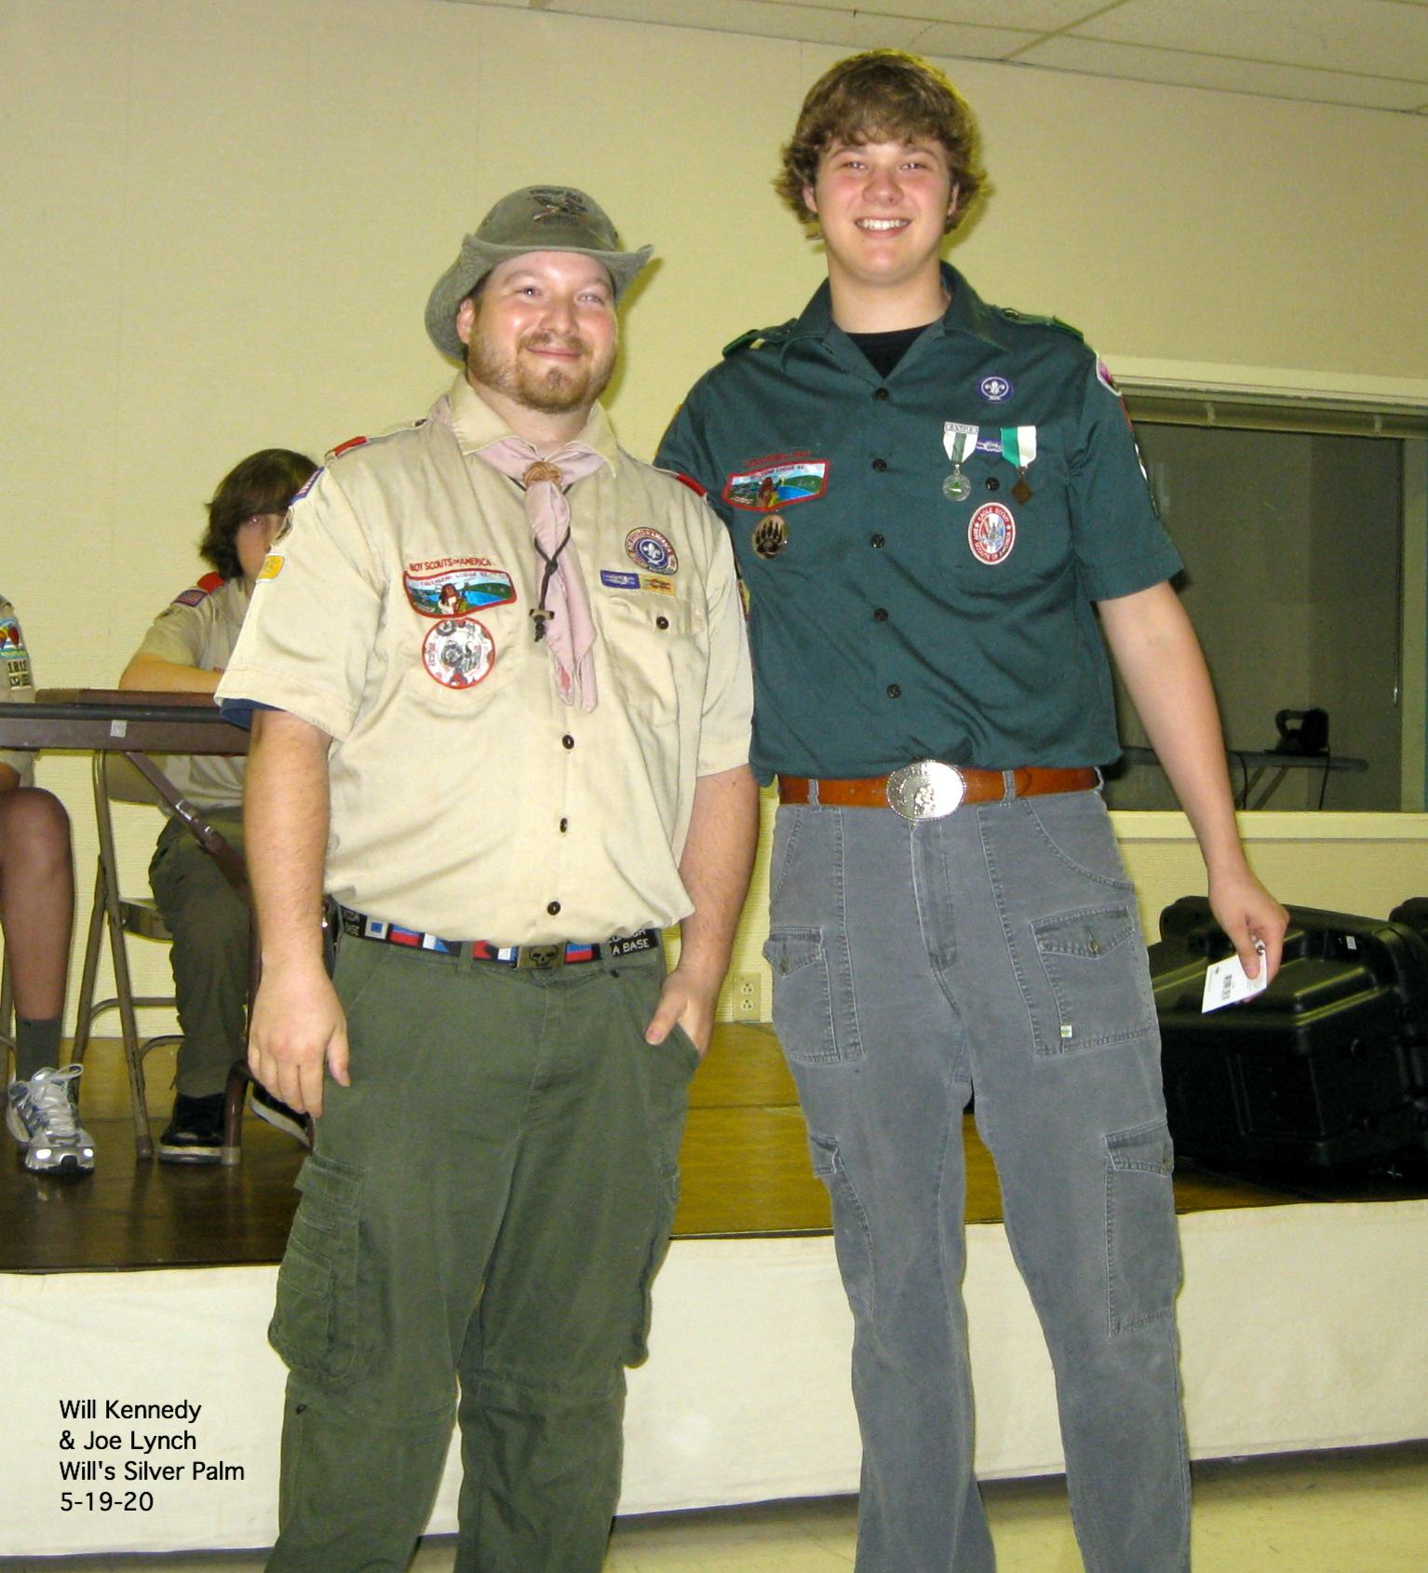
Also at the Court of Honor, Will Kennedy received his Silver Palm award. Upon achieving Eagle rank, a scout has until his 18th birthday to continue to earn merit badges and receive an Eagle Palm for every 5-merit badges earned. The Silver Palm is the highest palm that an Eagle Scout can earn which means Will earned 15 merit badges over and above those required to reach Eagle rank. To the right is Will being awarded his Silver Palm and Joe Lynch with him. Will earned this award right before turning 18. While he is no longer a member of Troop 243, we welcome his support of the scouts as a member of Venture Crew 243, also sponsored by St. Barnabas.

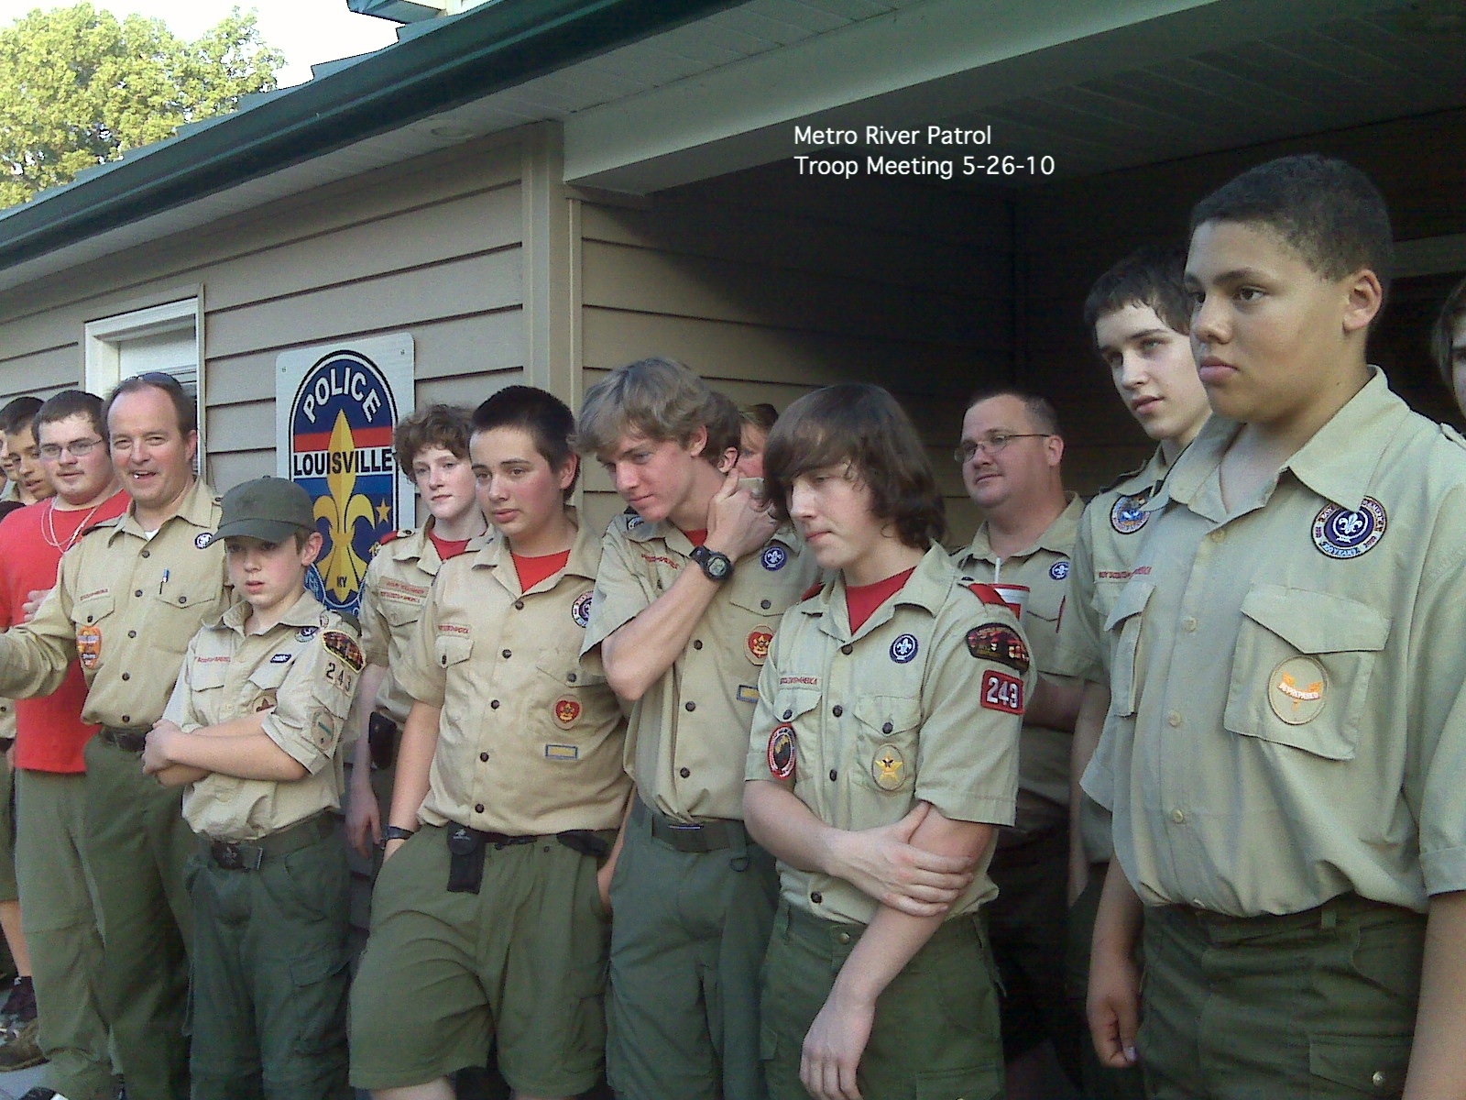
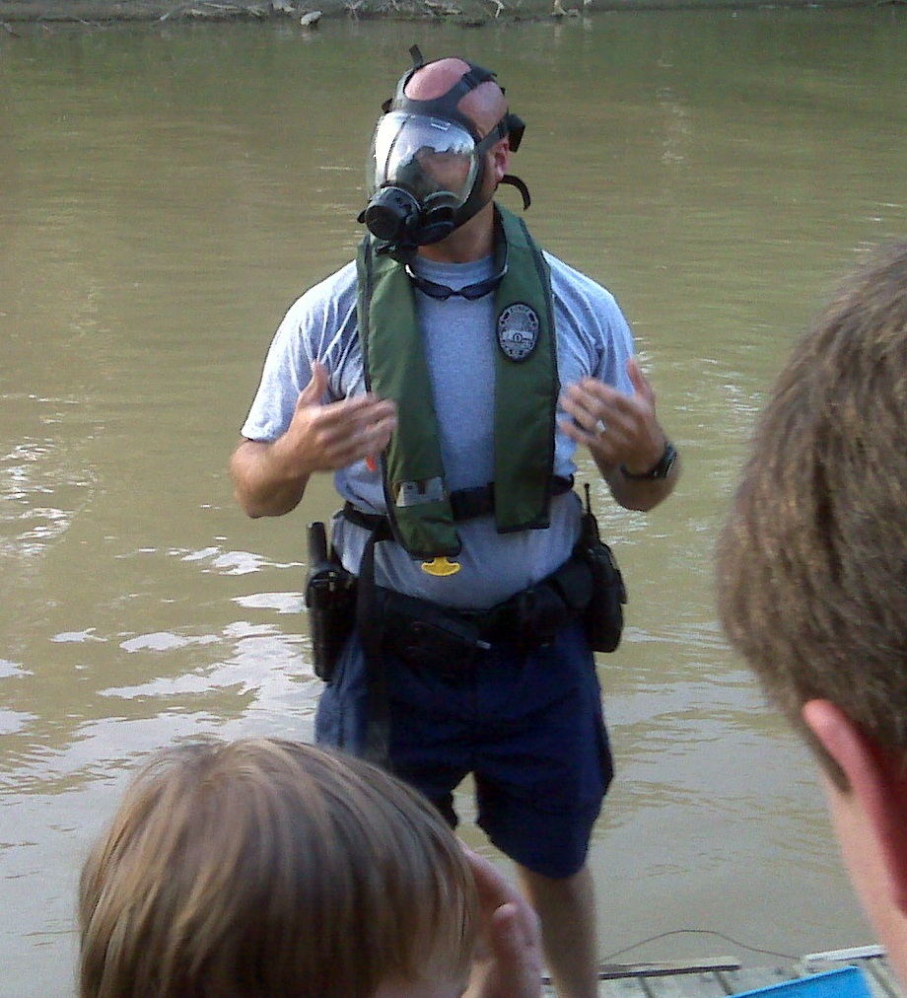
River Patrol Meeting – Patrol Advisor Vince Heuser arranged for our boys to visit with the Metro Louisville Police river patrol. Sgt. Mike Jacobs, pictured here with his gas mask on, demonstrated the various pieces of equipment that he and his fellow officers use to secure 37 miles of river and creeks. It is hard to say if Sgt. Jacob’s talk or some other piece of equipment is holding these scouts’ attention at this moment (Left picture.) Thank you Vince!

Order of the Arrow – The next chance to participate in the OA Ordeal Weekend and to join the Brotherhood is August 27th, 28th and 29th. If you are ready to continue with your OA commitment please sign up and take advantage of this opportunity to advance and have a fun weekend.

Troop Leadership meetings – The PLC meeting will be held on June 27th but there are no adult leadership meetings in June.

Advancement Update - Dates for the upcoming Boards of Review for advancement will be June 2 and 16th and July 7th. Please email Joe Tobin, Advancement Chairman, at jktobin@bellsouth.net if you would like to reserve a slot. Please review your rank advancement requirements in the handbook before your Board. You must appear in your complete class A uniform with current rank patch. If you are not in your complete uniform, your Board will be rescheduled. A Handout with the updated rank requirements from the 2010 Handbook will be distributed at the June 2 & 16th meetings. The new rank advancement requirements will be enforced at Boards of Review starting July 7th. Please review the changes before summer camp. The changes will only affect work on ranks that have begun after January 1, 2010. Work on ranks started before 2010 will be grandfathered under the old requirements. The July 7th meeting is for St. Barnabas Picnic setup with Scouts in work clothing. Any Scout having a BOR on July 7th should remember to bring their class A uniform and handbook with them to the meeting.

Pictures! – Frank Hulsman loaded all of Tom Kennedy's photo albums on the troop web site. These are pictures from various troop outings to be enjoyed by all. The links are broken down by year and activity. If you create your own ID, the system will let you download pictures. If anyone else has pictures on-line somewhere, they can send Frank a link and he’ll add it to the website. This is the link to view the pictures. http://www.troop243.com/page.php?page=photos

St. Barnabas’ Parish Picnic – July 10th is St. Barnabas’ annual parish picnic. It is our tradition to help the parish set up during the troop meeting on July 7th and help with parking during the picnic on July 10th. Please plan to help out so we can show our appreciation for St. Barnabas’ support.

Troop Gift Cards – Transportation to the vast majority of our outings is free to our scouts and leadership but it is not free. The cost of maintenance, fuel and insurance for our bus is paid by the Friends of Troop 243 which is funded by the Kroger and Thorntons gift card programs. We encourage all parents, members, relatives and friends to use Troop 243’s Kroger and Thorntons gift cards. Whenever you see Frank Hulsman at any function it is likely that he has a few gift cards with him. Please stop Frank at any time and ask him for one of these cards and he will be glad to give you one.

Miscellaneous – All three parts of the medical forms must be submitted to Jay Groves by June 6th if you are attending summer camp. A drug form must also be included

Yours in Scouting,
Bruce Bohn
Troop Secretary

